Here’s a quick guide to download files from a Google Drive link:

**Copy Paste /Open** <https://drive.google.com/drive/folders/1bl-25CdRHZ9iESavJaI4xpSySwmtr1mJ?usp=sharing>

**Access the Files**: The page will display the files available for download.

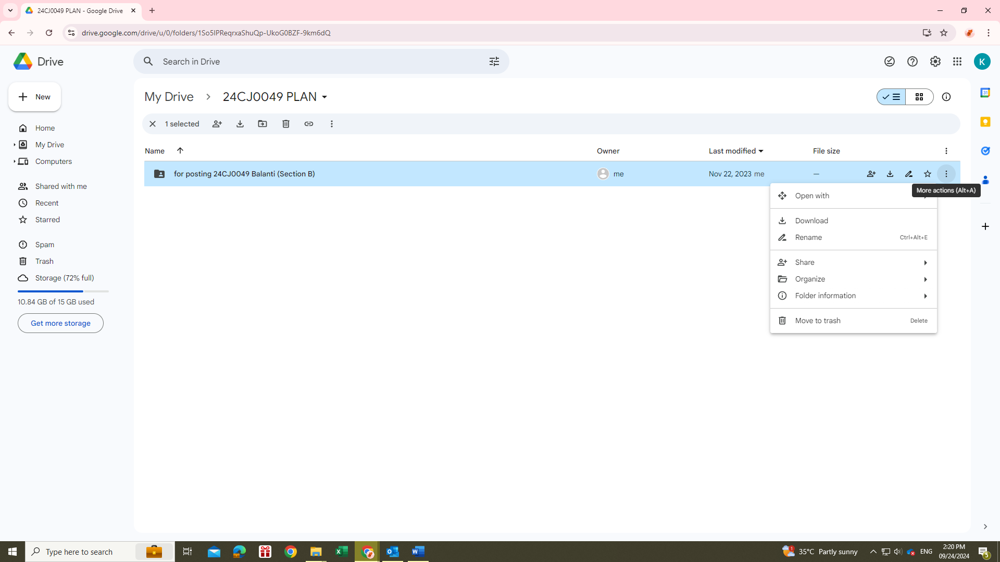

1. **Download Individual Files**: Right-click on the file you want and select **"Download."**

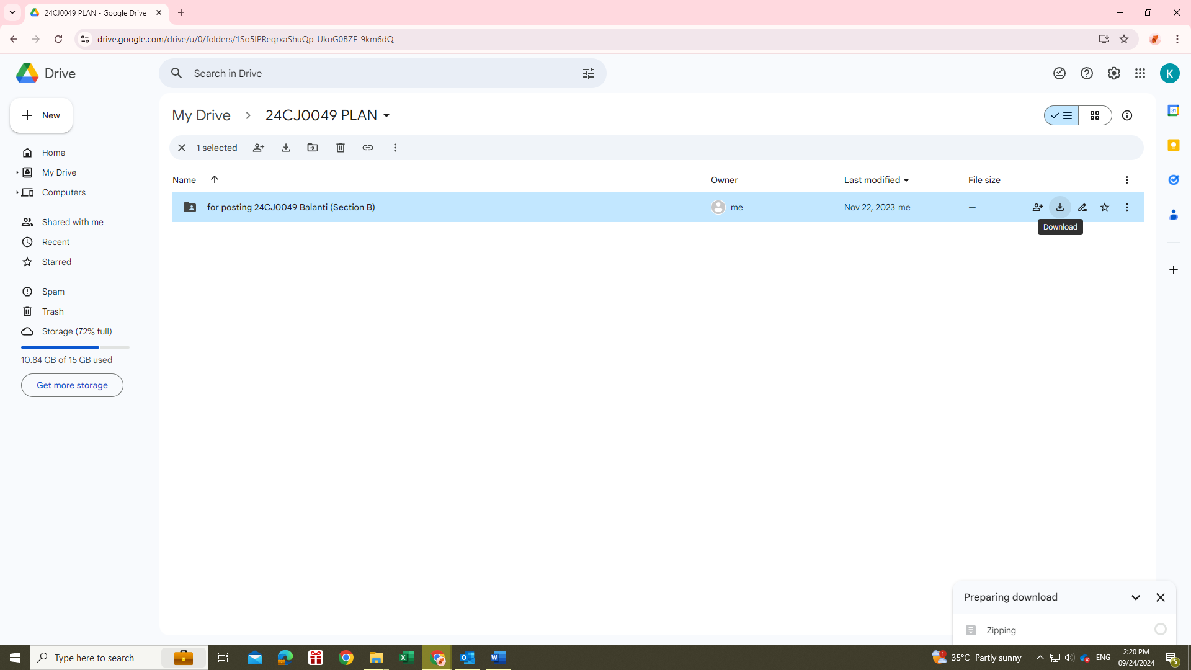

1. **Download Multiple Files**: Hold Ctrl (or Cmd on Mac) and click to select multiple files, then right-click and choose **"Download."** Google Drive will zip them into one folder for you.
2. **Locate the Downloaded Files**

Once the download is complete, navigate to your computer's downloads folder.

Find the downloaded files or the zipped folder containing multiple files.

1. **Step 6: Extract Files (if necessary)**

If you downloaded a zipped folder, right-click on it and select **"Extract All"** (or a similar option based on your operating system).

Follow the prompts to extract the files to your desired location.